**Analysis of Joint Odds-ratio distribution on the Training Dataset and Test Dataset:**

We executed the code 1000 times, generating 1000 joint odds ratio values.

1. Histogram Plots:

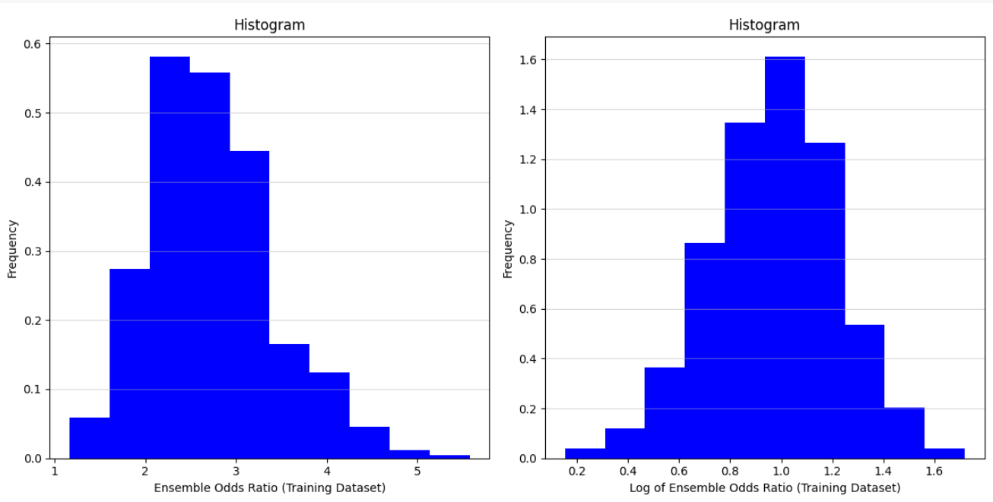

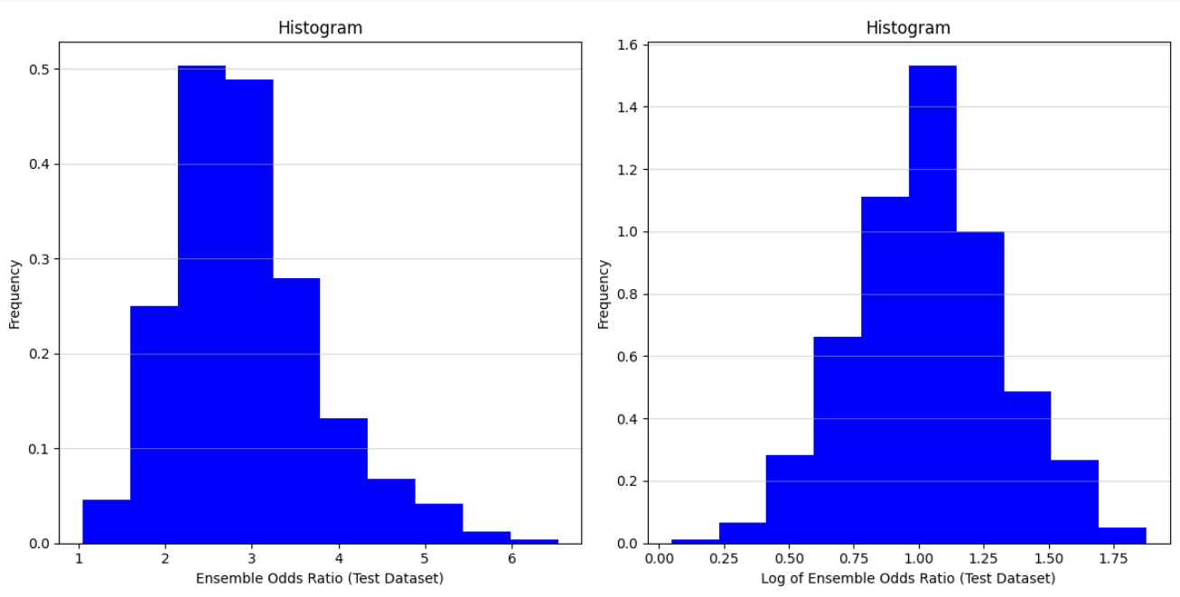

1. Comparison with Normal Distribution:

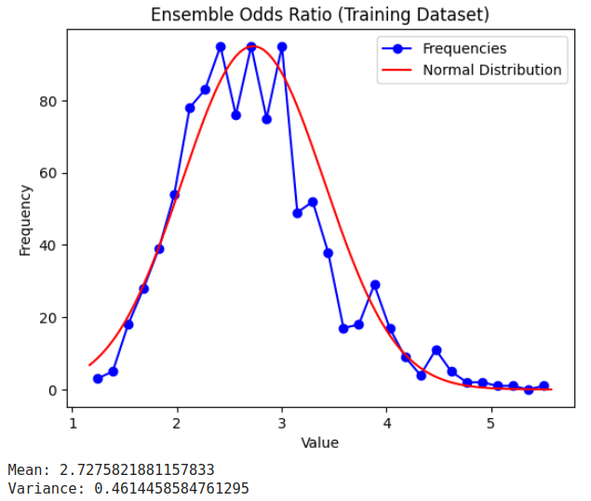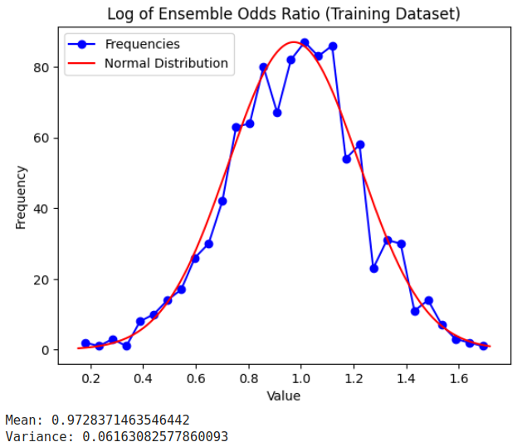

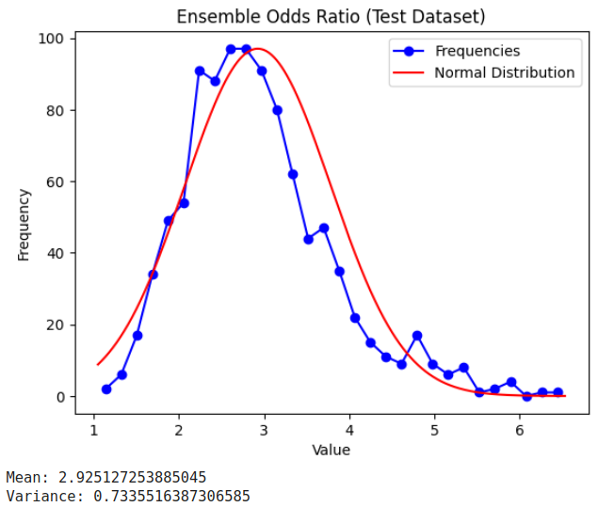 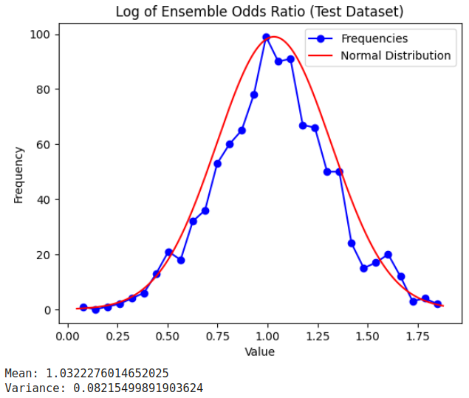

Observations:

1) We noted that the log of ensemble odds ratios for both the training and testing data approximates the

Normal distribution.

2) The mean value of the log of ensemble odd’s ratio in the training and test datasets is close to 1.

We need to see if this is dataset-specific or something related to Odd’s ratio.